ContactManagement_Verify Contact notes _Instance44_12-Jul-2018_07-52-28_AM_Validatingcontactentitynavigation.png

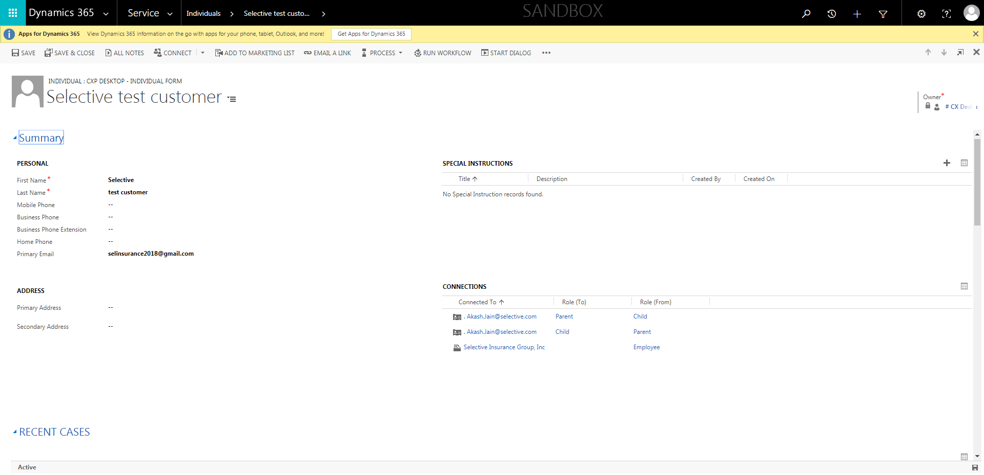

ContactManagement_Verify Contact notes _Instance44_12-Jul-2018_07-51-04_AM_MouseClickActiononStaleElement.png

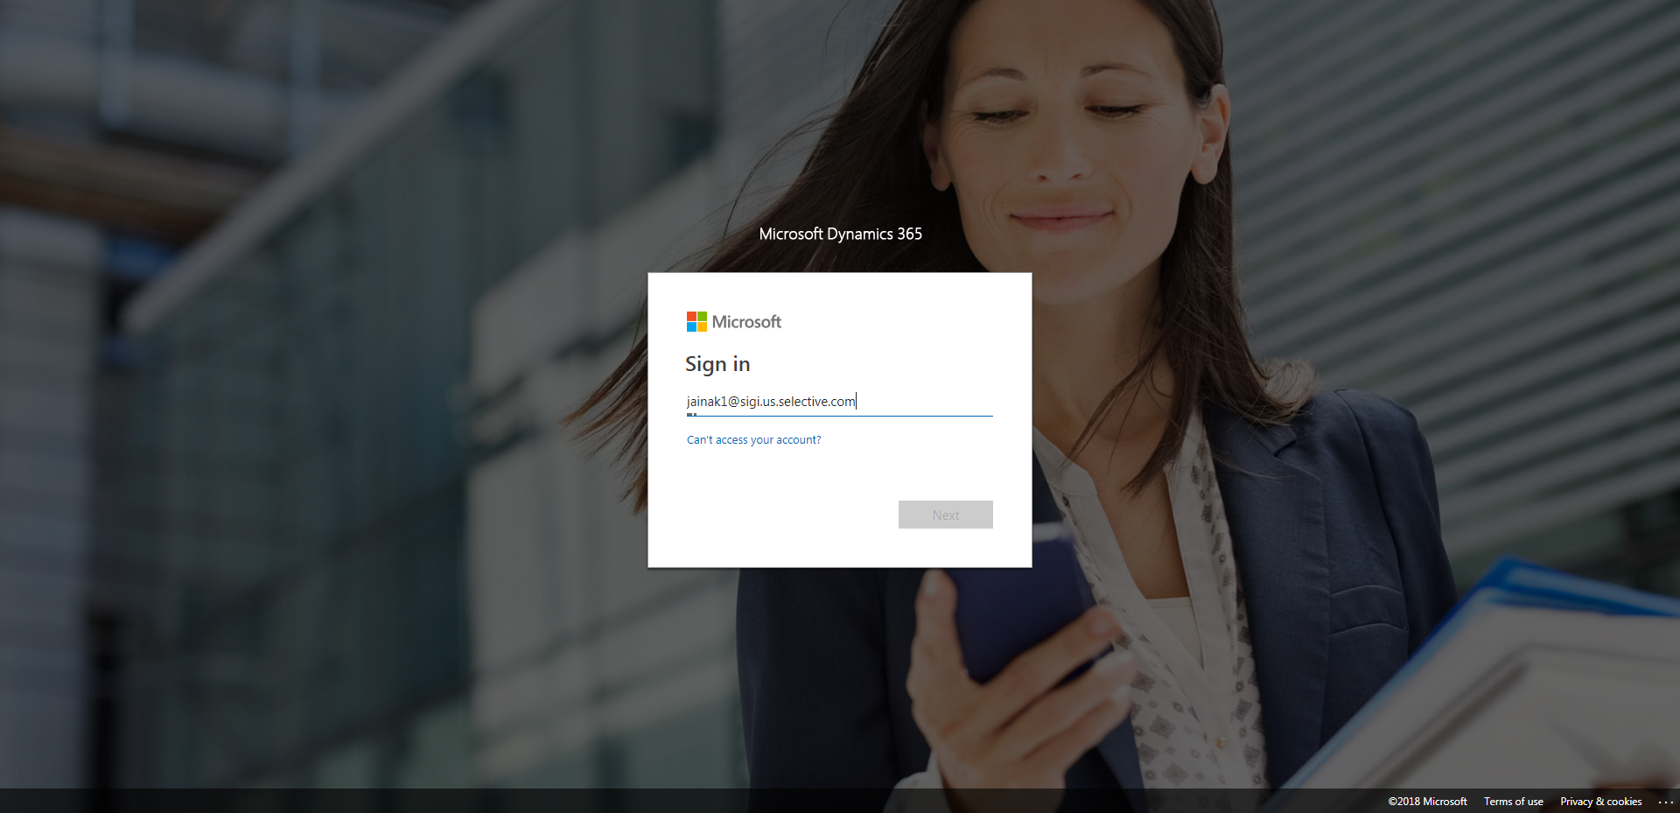

ContactManagement_Verify Contact notes _Instance44_12-Jul-2018_07-52-36_AM_VerifyingAllNotesofanindividual.png

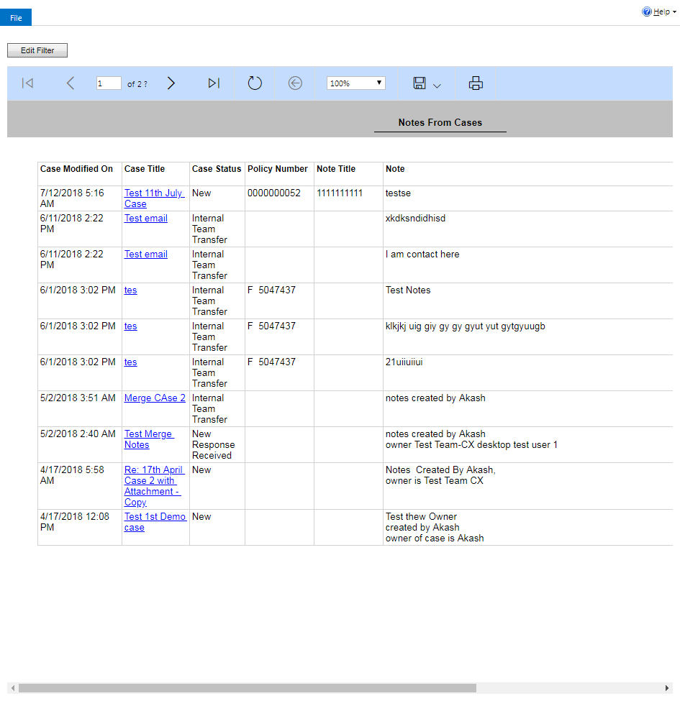

ContactManagement_Verify Contact notes _Instance44_12-Jul-2018_07-51-17_AM_SingleSignOn.png

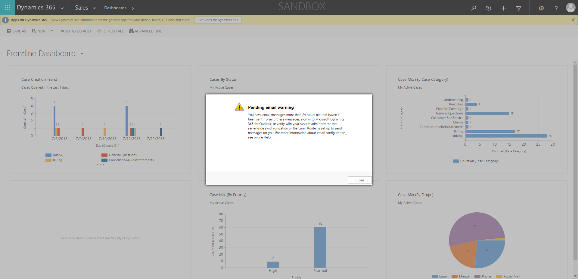

ContactManagement_Verify Contact notes _Instance44_12-Jul-2018_07-51-00_AM_MouseClickActiononStaleElement.png

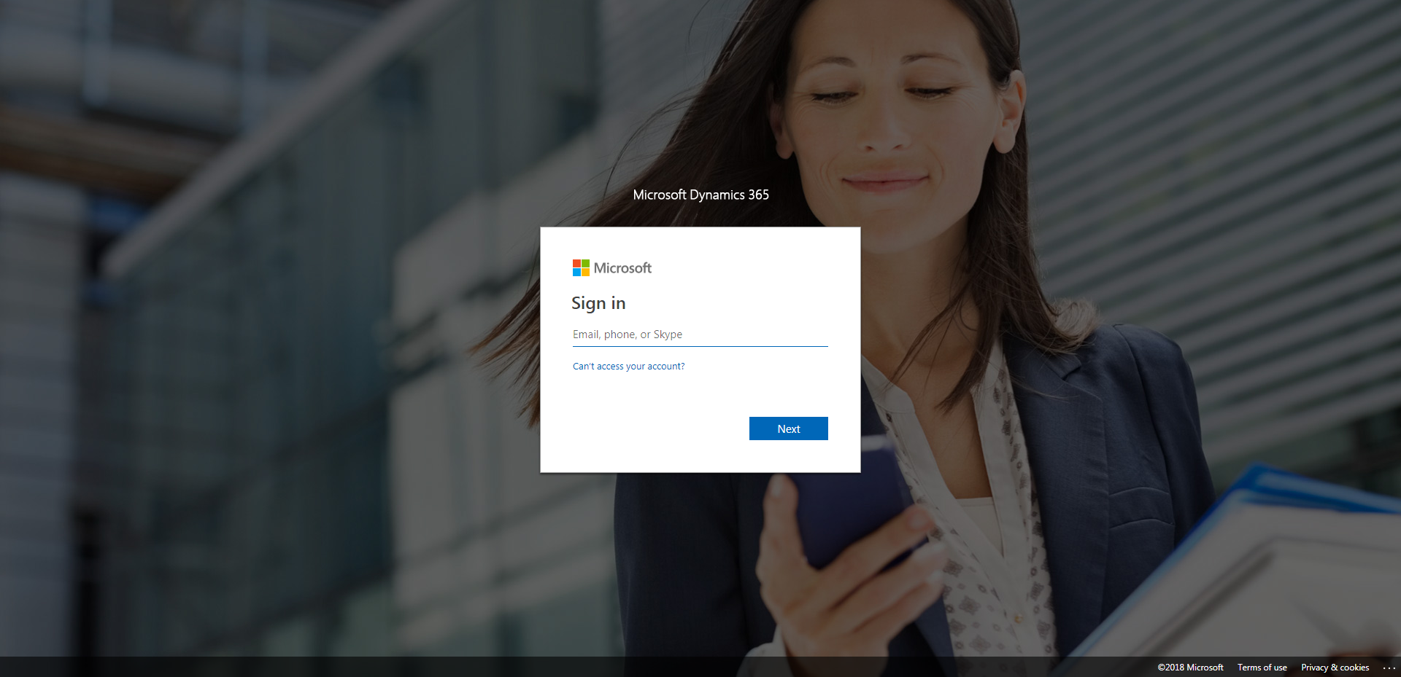

ContactManagement_Verify Contact notes _Instance44_12-Jul-2018_07-51-22_AM_SingleSignOn.png

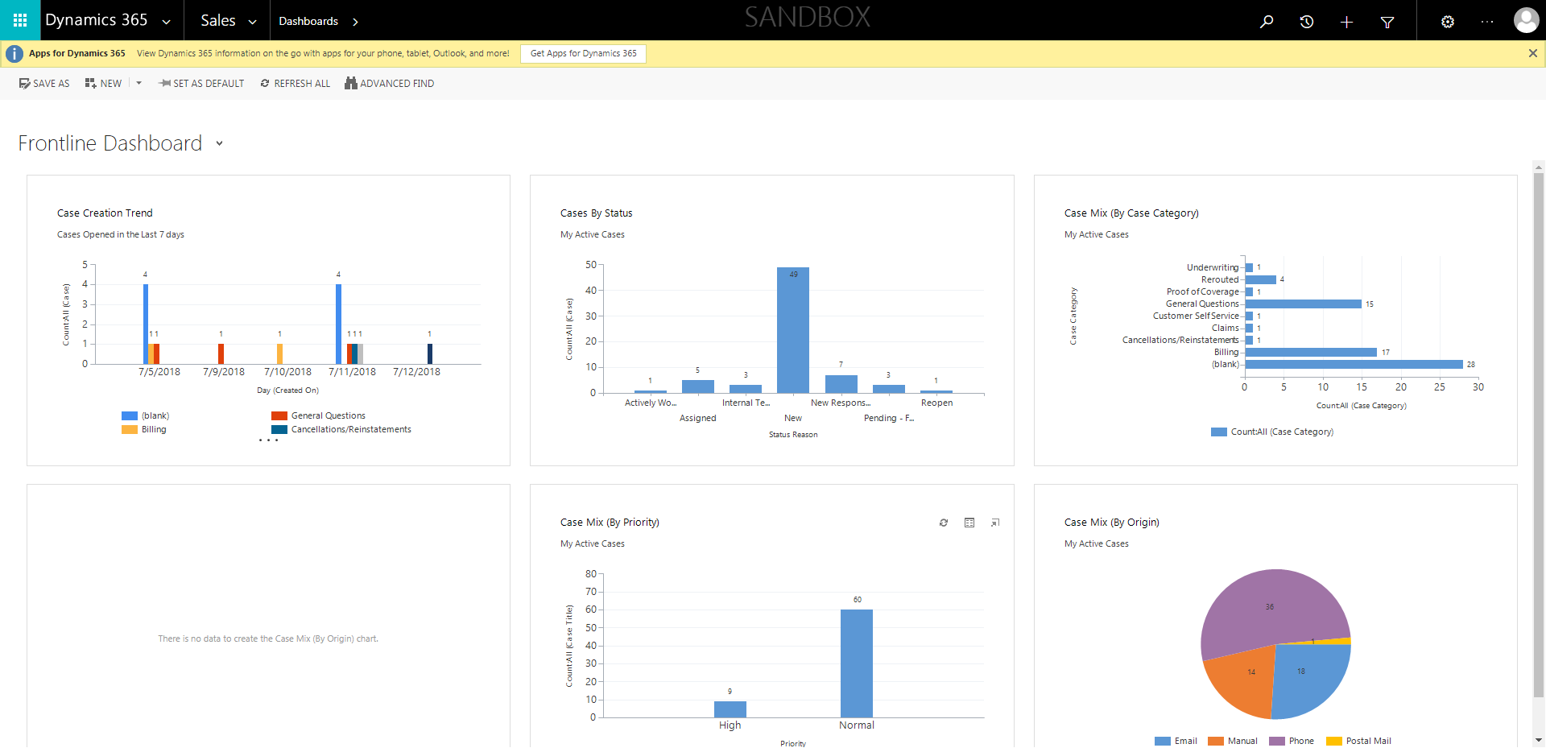

ContactManagement_Verify Contact notes _Instance44_12-Jul-2018_07-52-34_AM_VerifyingLatestNotesofanindividual.png



ContactManagement_Verify Contact notes _Instance44_12-Jul-2018_07-51-02_AM_EnterTextAction.png

